BLACKWATTLE BAY – YEAR 12 HALF YEARLY EXAM 2007

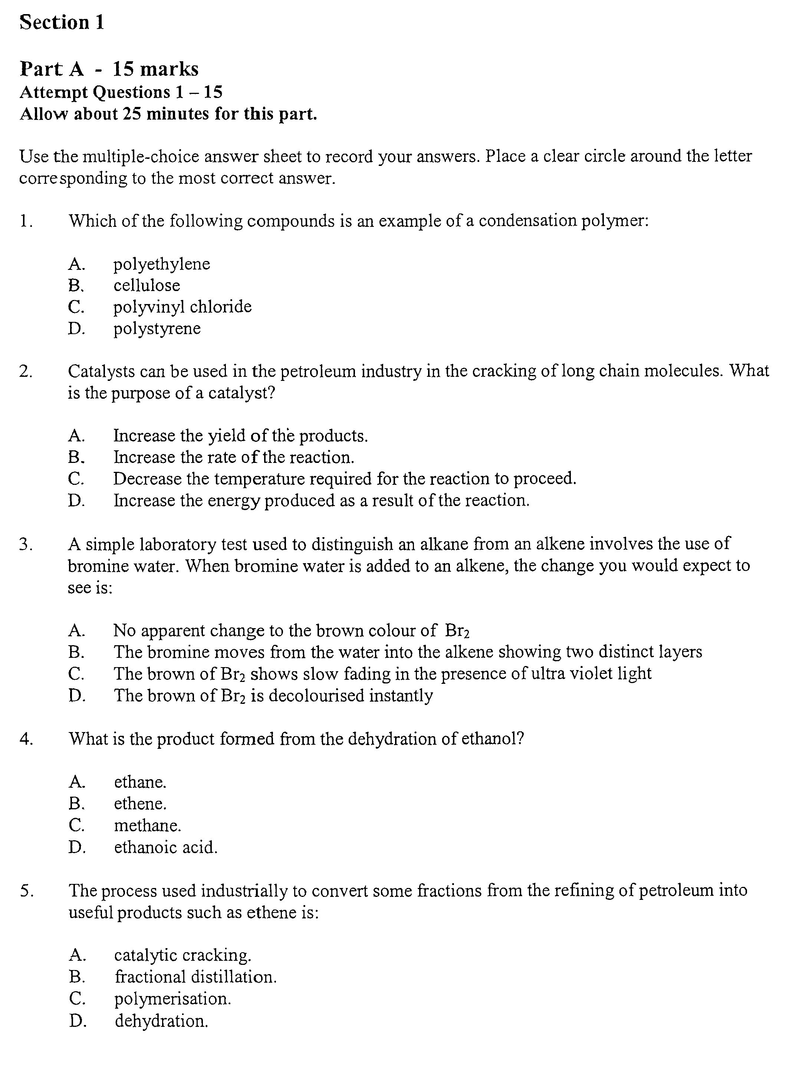

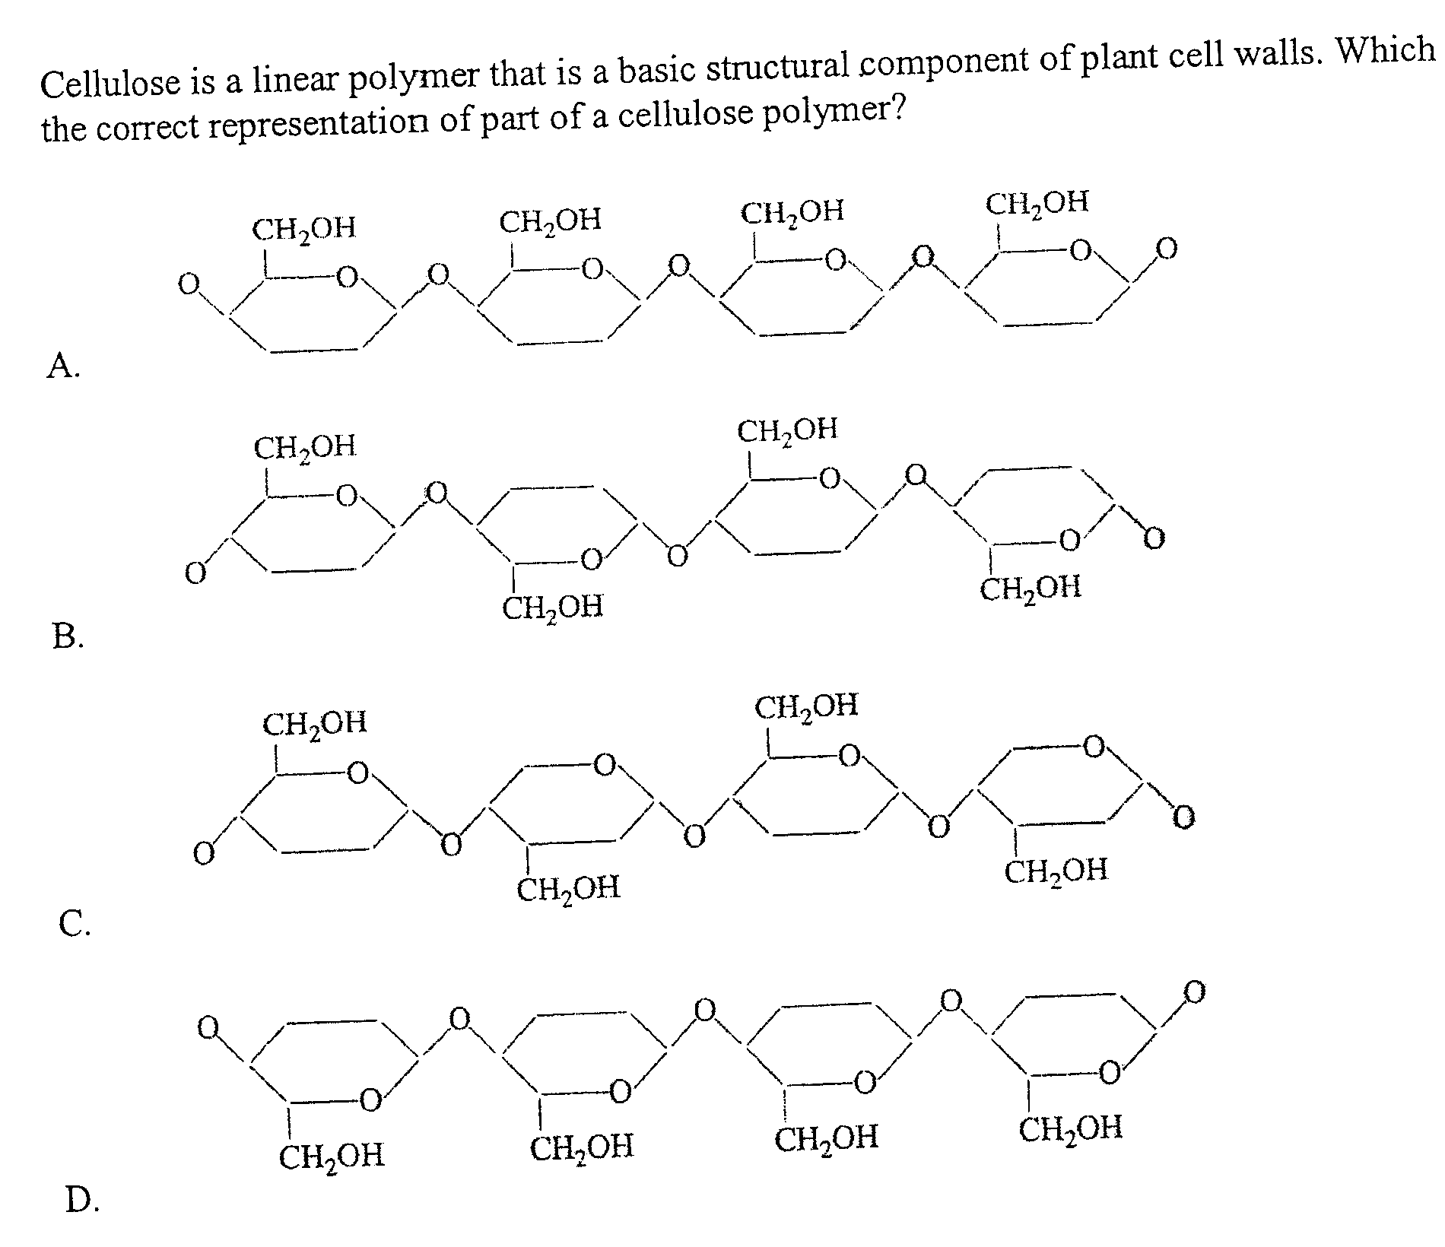
6.

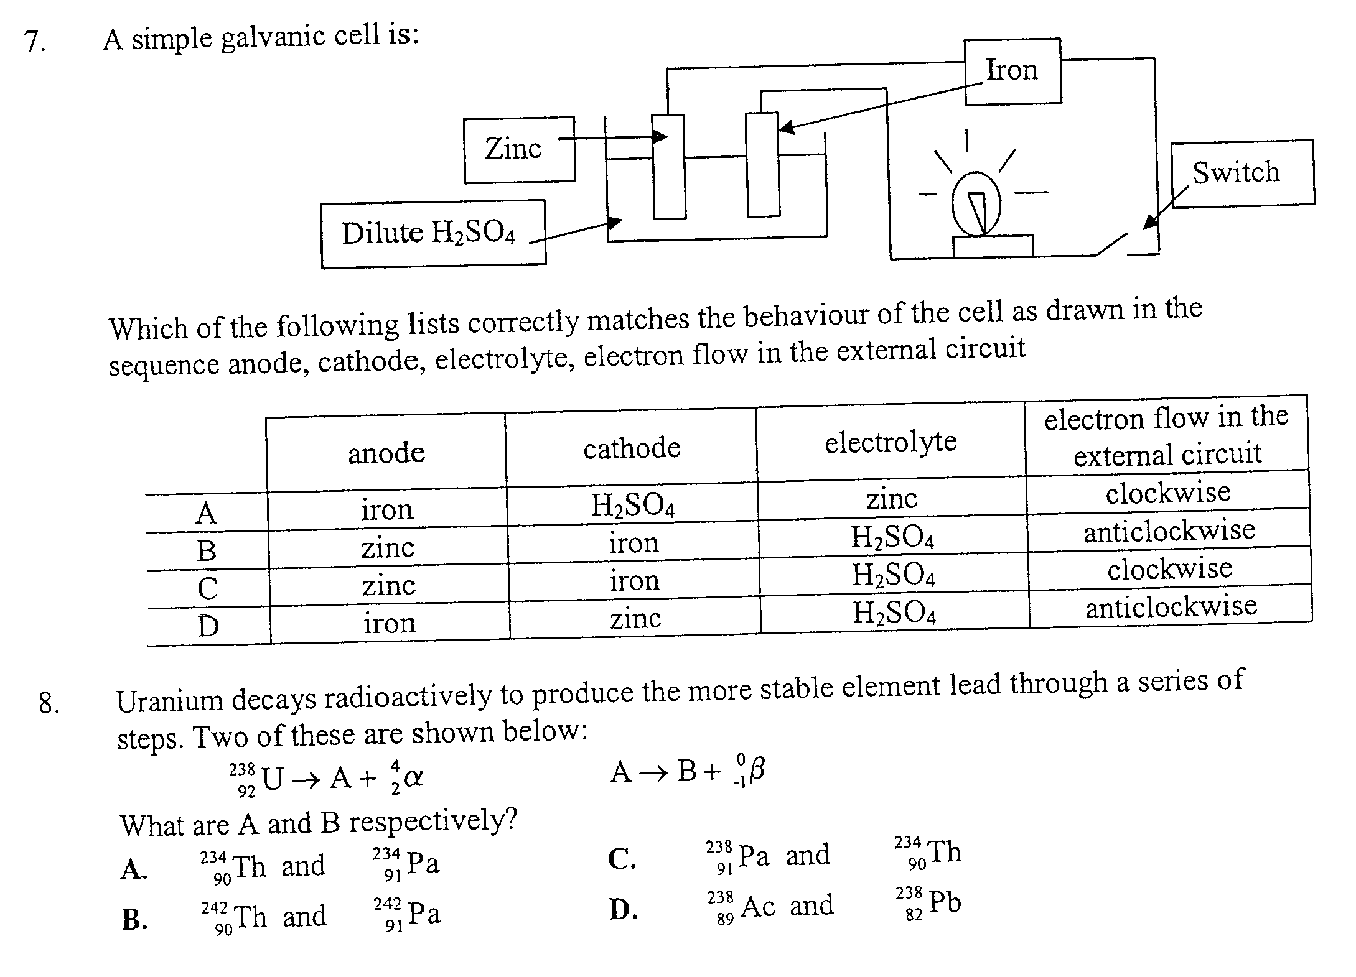

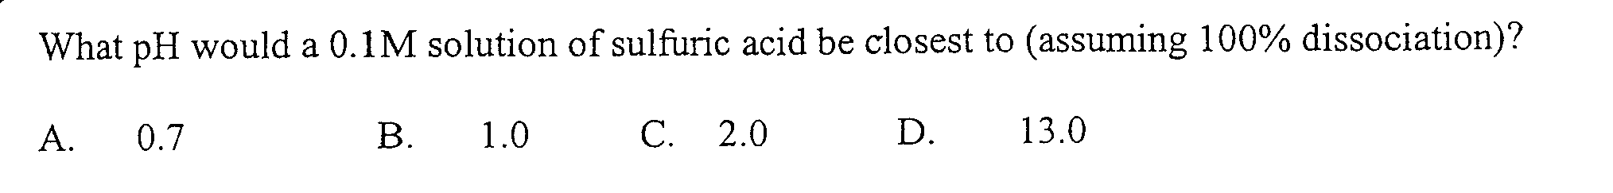
9.

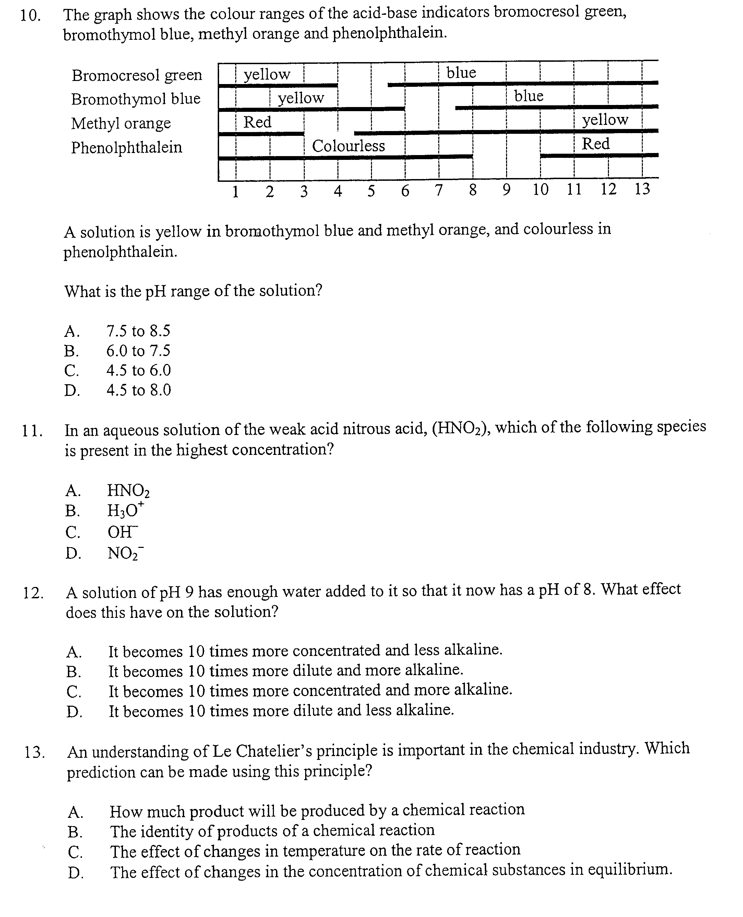

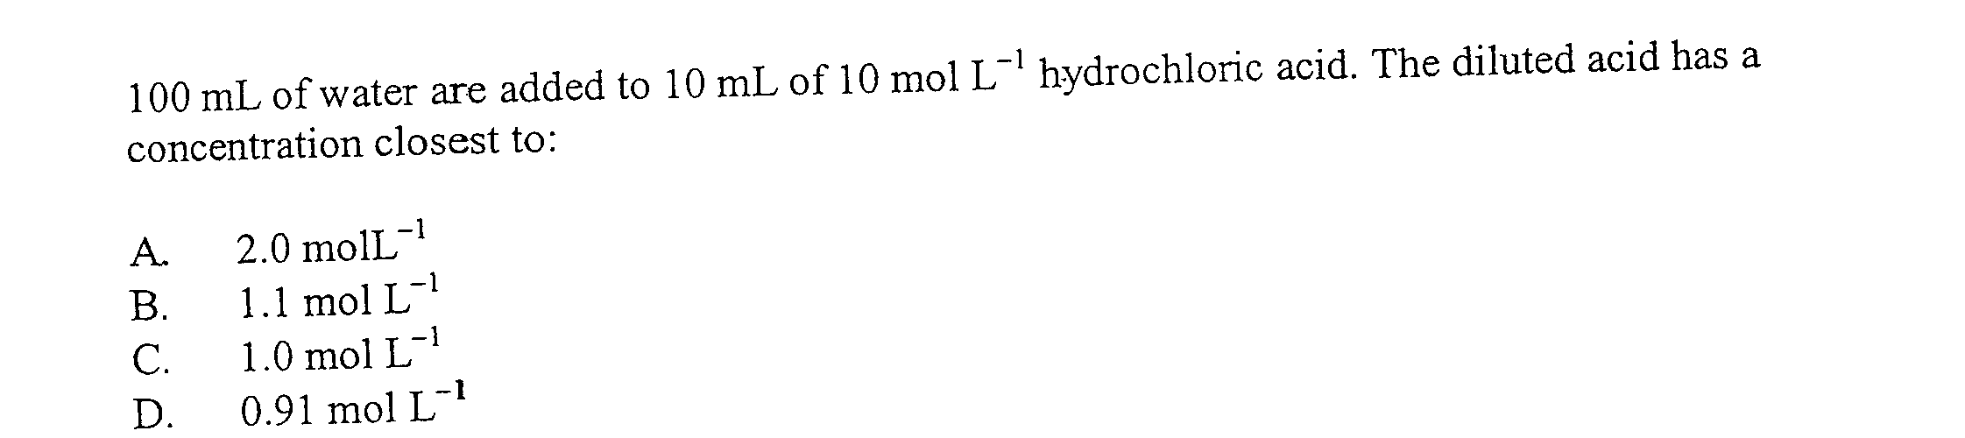
14. 100 mL of water are added to 10 mL of 10 molL⁻¹ hydrochloric acid. The diluted acid has a
concentration closest to:

A 2.0 molL⁻¹
B 1.1 molL⁻¹
C 1.0 molL⁻¹
D 0.91 molL⁻¹

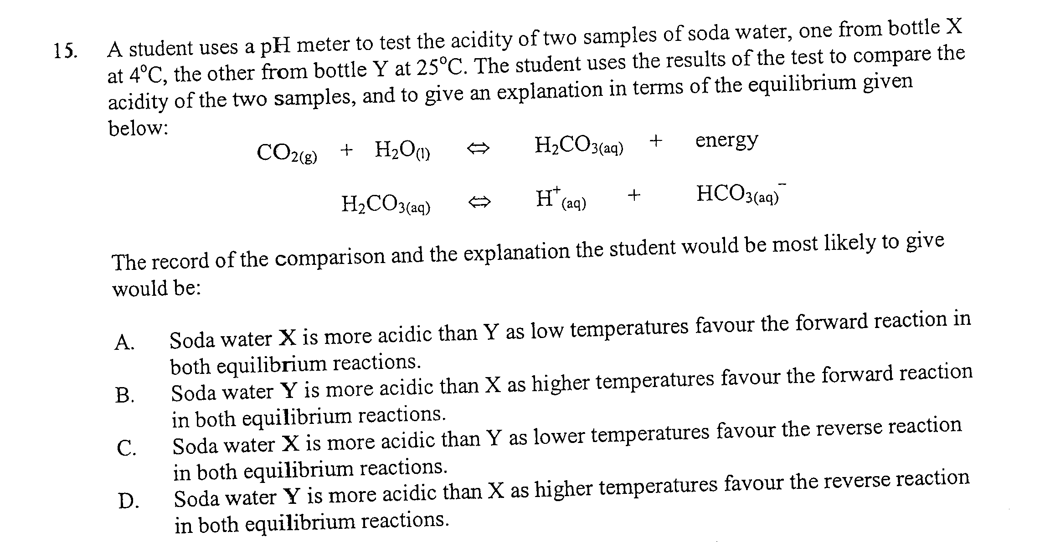

Part B - 55 marks
Attempt Questions 16-27
Allow about 1 hour and 35 minutes for this part

Answer the questions in the space provided
Show all relevant working in questions involving calculations

16. Explain why alkanes and their corresponding alkenes have similar physical properties but very
different chemical properties (2 marks)

…………………………………………………………………………………………………………

…………………………………………………………………………………………………………

…………………………………………………………………………………………………………

…………………………………………………………………………………………………………

…………………………………………………………………………………………………………

- Two types of polymer are addition polymers and condensation polymers. Select one of the polymers you have studied and:

a. Name the polymer you have selected, say whether it is an addition or condensation polymer and
describe how this polymer is formed giving clear details of the addition or condensation process
(2 marks)

…………………………………………………………………………………………………………

…………………………………………………………………………………………………………

…………………………………………………………………………………………………………

b. For the polymer you used in part a., draw the structural formula showing at least three monomer
units (1 mark)

18. Biomass can be converted to polythene by using the following synthesis route


a. Name step 2 and identify the conditions necessary for the formation of compound X (1 mark)

…………………………………………………………………………………………………………

…………………………………………………………………………………………………………

b. Draw the structural formulae, and give the systematic names for, each of the compounds (2 marks)

c. Identify the conditions necessary for step 3 and name the process involved (1 mark)

…………………………………………………………………………………………………………

…………………………………………………………………………………………………………

d. Write a balanced reaction equation to represent the reaction involved in step 2 (1 mark)

…………………………………………………………………………………………………………

19. Identify the parent alkane and give the systematic (IUPAC) name, for each of the compounds
shown below (3 marks)
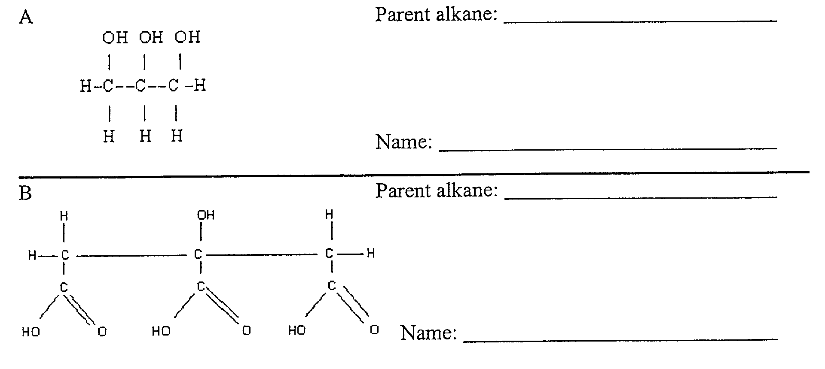

20. a. Name ONE type of cell other than the dry cell or lead-acid cell you have studied (1 mark)

…………………………………………………………………………………………………………

b. Evaluate the named cell in comparison with either the dry cell or lead-acid cell, in terms of
chemistry and the impact on society. Include relevant chemical equations in your answer
(4 marks)

…………………………………………………………………………………………………………

…………………………………………………………………………………………………………

…………………………………………………………………………………………………………

…………………………………………………………………………………………………………

…………………………………………………………………………………………………………
21. a. Ethanol is an organic chemical with the potential to be used as an alternative fuel to fossil fuels.
Discuss ONE advantage and ONE disadvantage of ethanol as an alternative to fossil fuels
(2 marks)

…………………………………………………………………………………………………………

…………………………………………………………………………………………………………

…………………………………………………………………………………………………………

…………………………………………………………………………………………………………

…………………………………………………………………………………………………………

22. A student used each of the following spirit burners to determine the heat of combustion of each
fuel. They did this by heating 200 mL of water in a beaker over each burner for 2 minutes

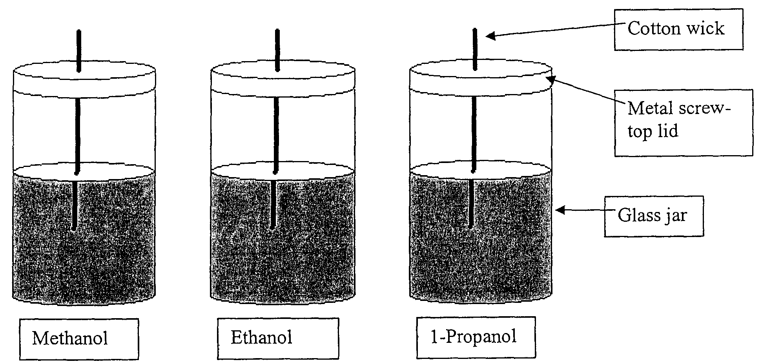

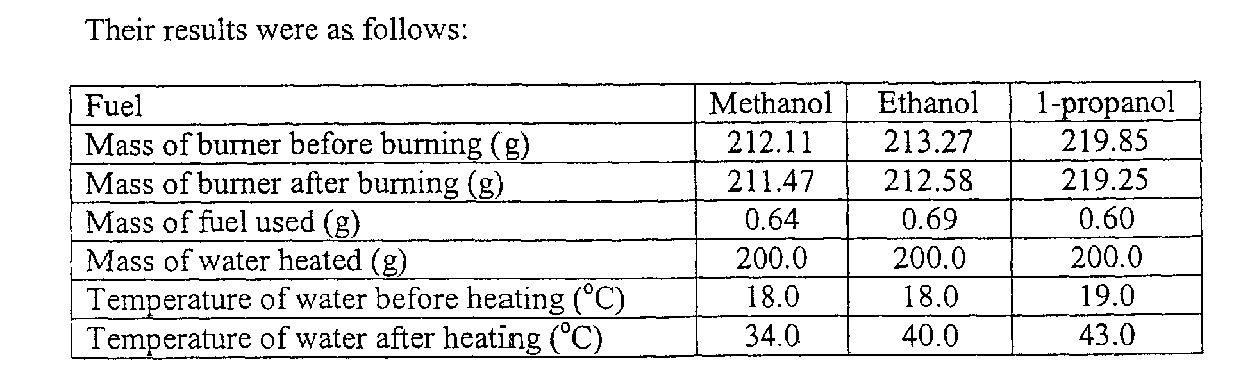

a. Write a balanced equation for the combustion of ethanol. Include states (1 mark)

…………………………………………………………………………………………………………

b. Calculate the molar heat of combustion of ethanol (2 marks)

…………………………………………………………………………………………………………

…………………………………………………………………………………………………………

…………………………………………………………………………………………………………

c. Give two reasons why this value is less than the theoretical value of -1364 kJmol⁻¹ (1 mark)

…………………………………………………………………………………………………………

…………………………………………………………………………………………………………

23. The diagram below shows a Galvanic cell:
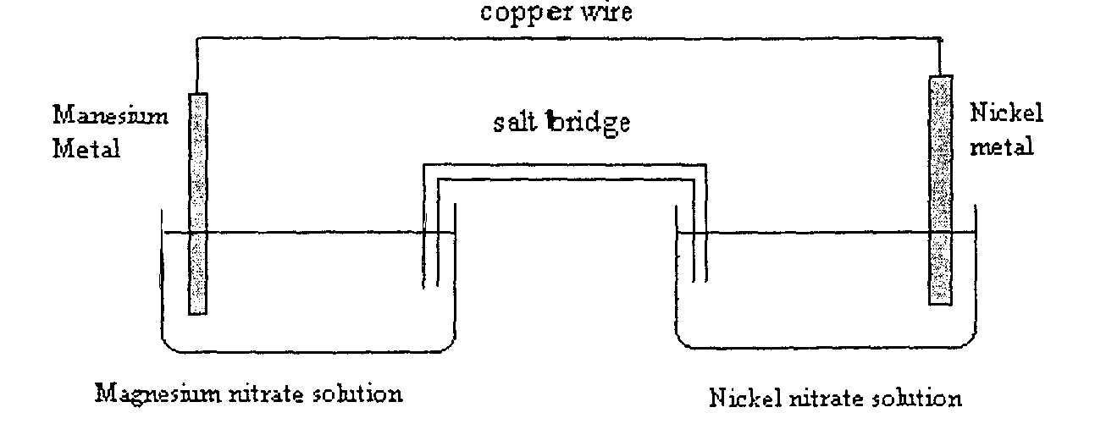

a. Using the standard potentials table on the data sheet, calculate the theoretical voltage of this
galvanic cell (2 marks)

…………………………………………………………………………………………………………

…………………………………………………………………………………………………………

b. Identify the anode of the cell. Justify your answer

…………………………………………………………………………………………………………

…………………………………………………………………………………………………………

24. “Radioactive dating” is the name of the process used to determine the age of many types of
materials including rocks found in the Earth’s crust. This process has been used on some of the
very oldest rocks known using the uranium-238 isotope

a. Write an equation to represent the β decay of uranium-238 (1 mark)

…………………………………………………………………………………………………………

b. Identify an instrument that could be used to detect the radiation emitted from a radioisotope such as
uranium-238 (1 mark)

…………………………………………………………………………………………………………

c. Other radioisotopes are used in medicine for both diagnosis and treatment. Give an example of a
radioisotope used and analyse benefits associated with the use of this isotope (2 marks)
…………………………………………………………………………………………………………

…………………………………………………………………………………………………………

…………………………………………………………………………………………………………

…………………………………………………………………………………………………………

25. A small amount of pure magnesium metal is dropped into 0.3 L of 1.5 M HCl. The reaction is
summarised in the following equation:

Mg_{(s)} + 2HCl_{(aq)} → MgCl_{2(aq)} + H_{2(g)}

The gas collected occupied a volume of 4.68 L at 25ºC and 1 atm pressure

a. Calculate the amount in moles of gaseous product (1 mark)

…………………………………………………………………………………………………………

…………………………………………………………………………………………………………
b. Calculate the final pH of the remaining solution (3 marks)

…………………………………………………………………………………………………………

…………………………………………………………………………………………………………

…………………………………………………………………………………………………………

…………………………………………………………………………………………………………

26. In a first hand investigation, a group of students used a computer probe to measure the pH of
equimolar solutions of 4 acids. Their results are recorded in the table given below:
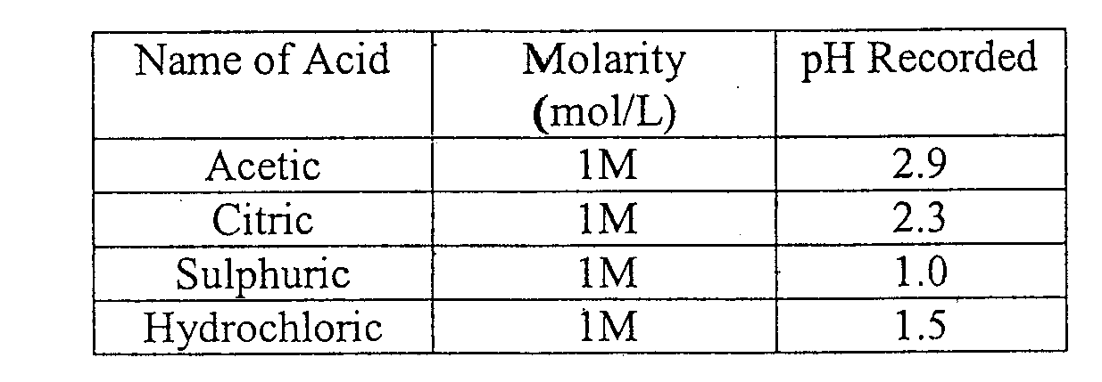

Explain the differences in the pH values of:

a. Sulfuric acid and hydrochloric acid (2 marks)

…………………………………………………………………………………………………………

…………………………………………………………………………………………………………

…………………………………………………………………………………………………………

…………………………………………………………………………………………………………

b. Acetic acid and hydrochloric acid (2 marks)

…………………………………………………………………………………………………………

…………………………………………………………………………………………………………

…………………………………………………………………………………………………………

27. Barium hydroxide and sulfuric acid react according to the following equation:

Ba(OH)_{2(aq)} + H₂SO_{4(aq)} → BaSO_{4(s)} + 2H₂O_{(l)}

a. Name this type of chemical reaction (1 mark)

…………………………………………………………………………………………………………
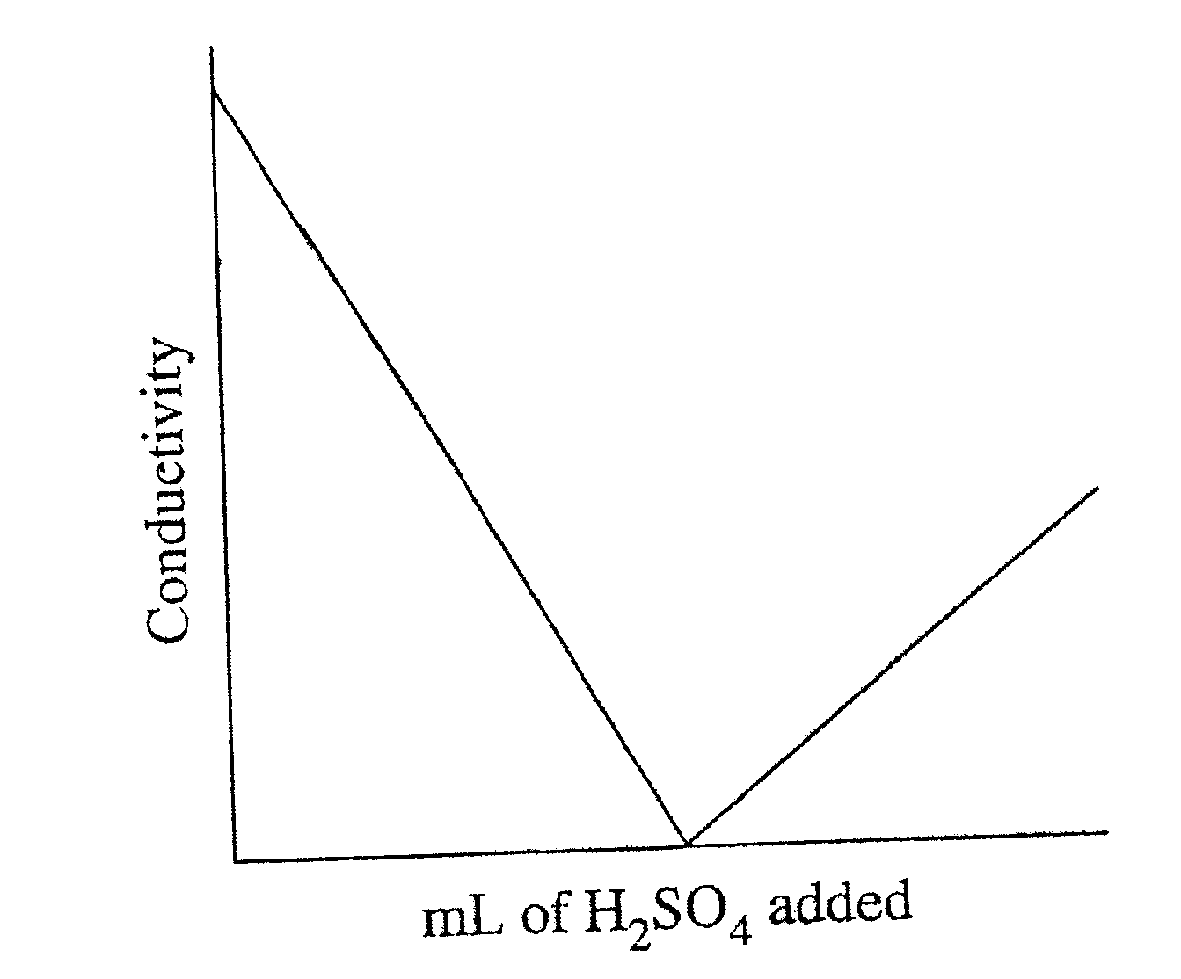
b. A 20 mL sample of barium hydroxide was placed in
a flask. A 0.12 mol/L solution of sulfuric acid
was slowly added to the barium hydroxide. The
electrical conductivity of the solution was
measured throughout this process and the results
graphed as shown

Explain the changes in conductivity shown by the graph in terms of what is present in the flask
(3 marks)

…………………………………………………………………………………………………………

…………………………………………………………………………………………………………

…………………………………………………………………………………………………………

…………………………………………………………………………………………………………

…………………………………………………………………………………………………………

…………………………………………………………………………………………………………

…………………………………………………………………………………………………………

…………………………………………………………………………………………………………

28. The accuracy of acid-base titrations depends on several factors. These include the primary
standard used, how the glassware is prepared and how the equivalence point is determined

a. Explain why sodium hydroxide is not used as a primary standard (1 mark)

…………………………………………………………………………………………………………

…………………………………………………………………………………………………………

b. During a titration, a conical flask is prepared by rinsing it with distilled water. While this flask is
still wet, a clean dry pipette is used to transfer 20 mL of a standard solution into it. Will the
accuracy of the titration be affected? Explain your answer (2 marks)

…………………………………………………………………………………………………………

…………………………………………………………………………………………………………

…………………………………………………………………………………………………………

29. In a sealed container, gases A and B react to form gases C and D but the reaction does not
proceed to completion.

A + B ⬄ C + D
The graph below shows the way in which the composition of the reaction chamber changes over
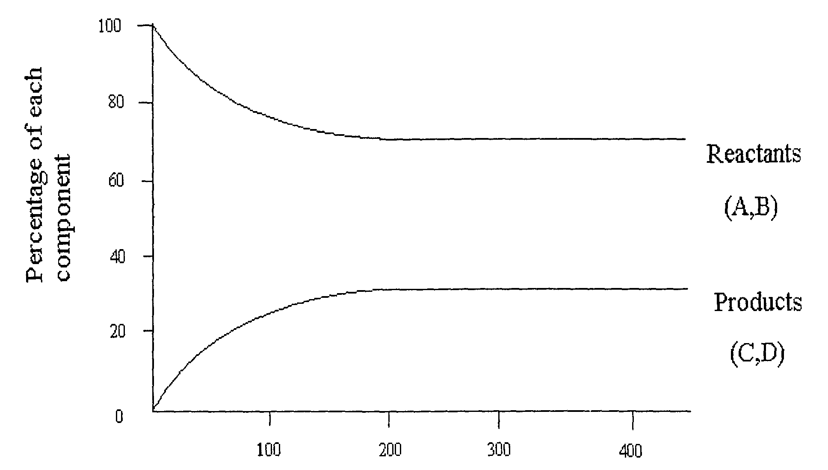
time

- At what time was equilibrium first established?

…………………………………………………………………………………………………………
Question 29 cont.

b. At 300 minutes, is any reaction still occurring? Explain (2 marks)

…………………………………………………………………………………………………………

…………………………………………………………………………………………………………

…………………………………………………………………………………………………………

…………………………………………………………………………………………………………

c. The reaction is repeated by mixing C and D together (at the same temperature). The system is
allowed to come to equilibrium. On the axis below, sketch a graph of the percentage of each
component as a function of time (2 marks)

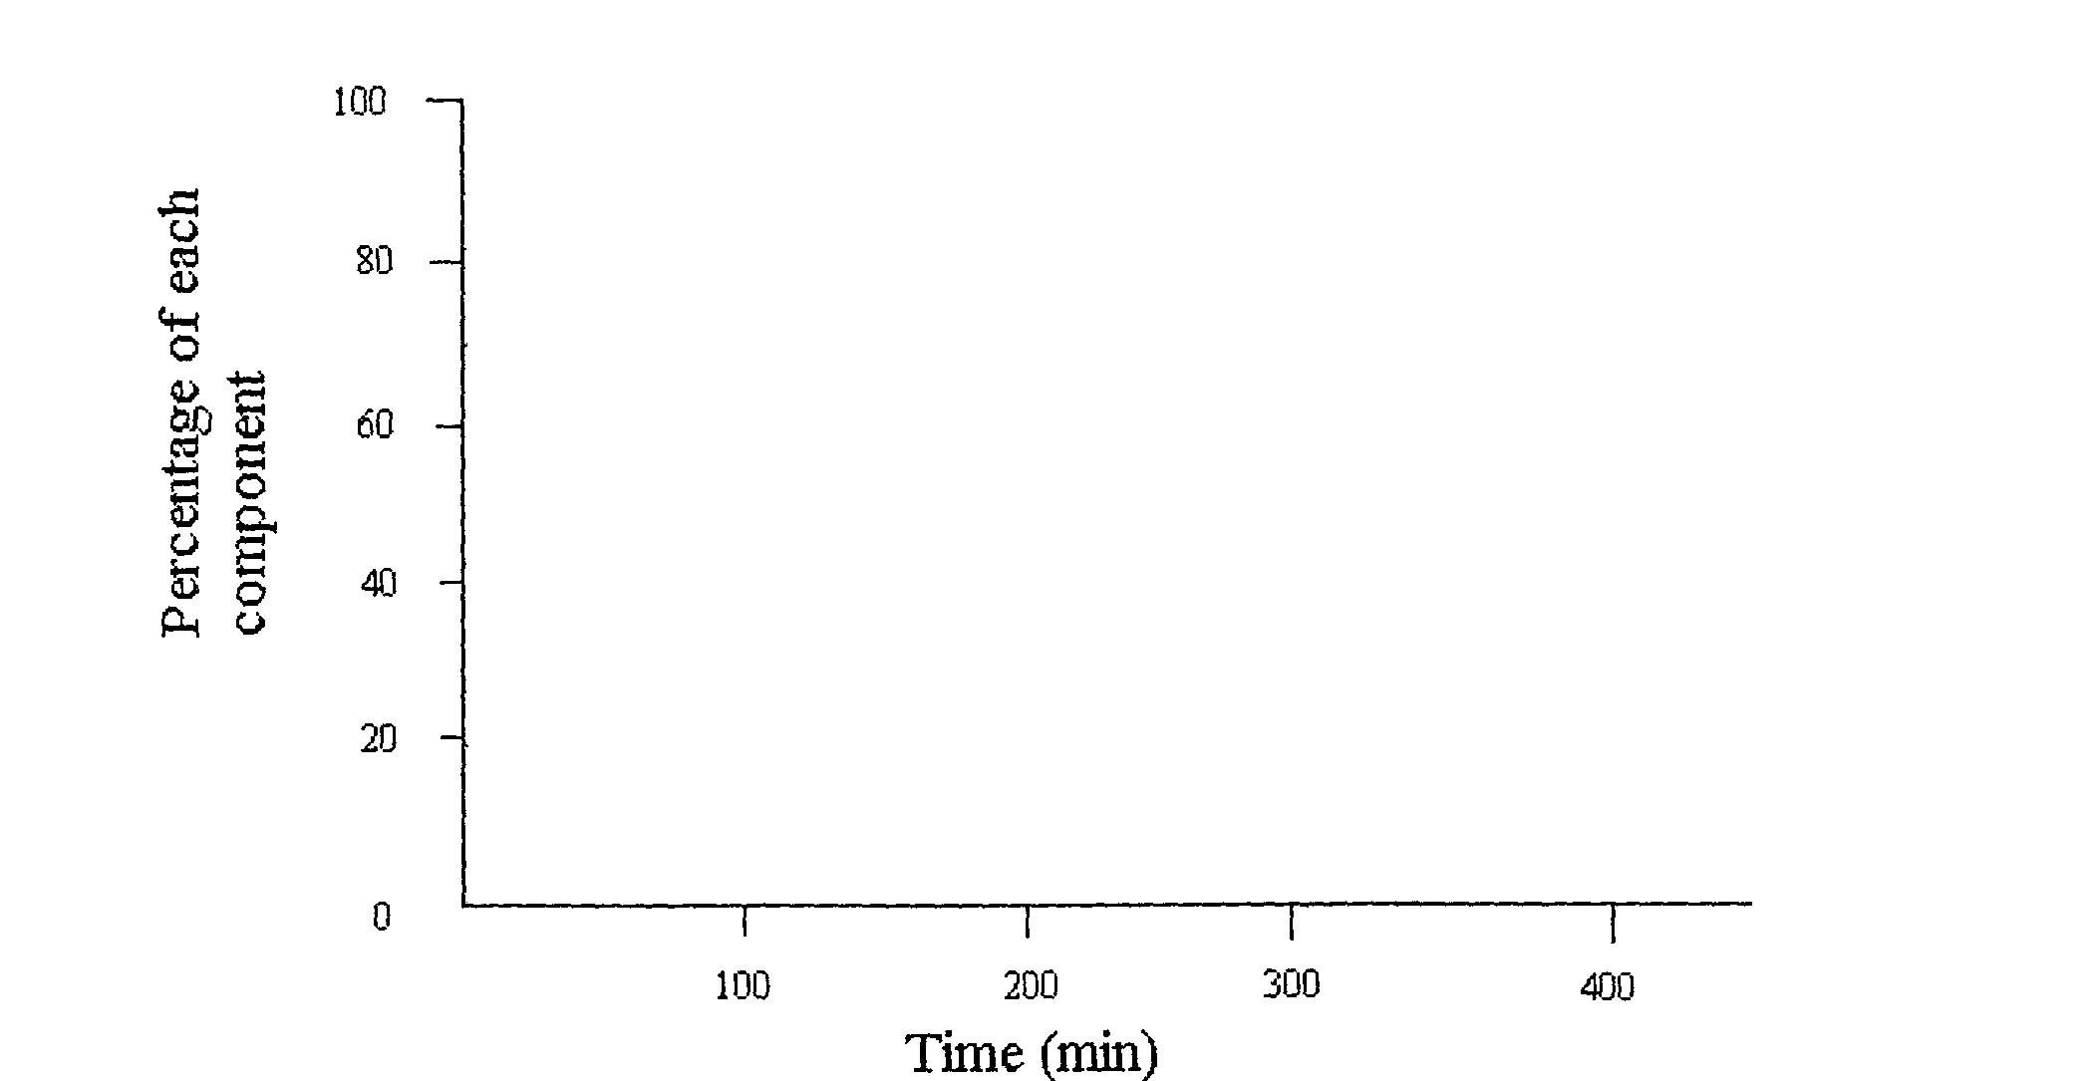

30. The power industry in Australia gains most of its energy from coal. One pollutant produced by
the burning of coal is sulphur dioxide that can escape into the atmosphere

a. Sulfur dioxide can result in the formation of acid rain. Write a balanced reaction equation showing
the reaction of sulfur dioxide with water to form an acid (1 mark)

…………………………………………………………………………………………………………

b. Give two harmful effects of acid rain (1 mark)

…………………………………………………………………………………………………………

…………………………………………………………………………………………………………

c. Name one other air pollutant that contributes to the formation of acid rain and name a major source
of this pollutant (2 marks)

…………………………………………………………………………………………………………

…………………………………………………………………………………………………………

